Exploring South African Physicians’ Acceptance of e-Prescribing Technology
XXXXXX
ª University XX

Abstract
e-Prescribing systems hold promise for improving the quality and efficiency of the scripting process. Yet, the use of the technology has been associated with a number of challenges. The diffusion of e-prescribing into physician practices and the consequent realization of its potential benefits will depend on whether physicians are willing to accept and engage with the technology. This study draws on the Unified Theory of Acceptance and Use of Technology to better understand South African physicians’ perceptions of e-prescribing. Data was collected from a sample of 72 physicians. Results indicate a general acceptance of e-prescribing amongst physicians who on average reported strong intentions to use e-prescribing technologies if given the opportunity. A number of factors exhibited significant correlations with acceptance. Performance expectancy and trust were the most strongly correlated whilst facilitating conditions and social influence had less significant effects.

Keywords:
Electronic prescriptions, technology acceptance, UTAUT

Introduction
Electronic prescribing or e-prescribing is the use of information technology to support physician decision making in the capture, review and issue of medication prescriptions [1]. In addition to replacing the physician’s prescription pad, e-prescribing systems provide a wide range of functions [2, 3, 4, 5]. For example, they can integrate into other patient management systems or provide stand-alone functionality for display of patient demographic, medical and medication history information. They provide clinical decision support through inclusion of formulary lists, drug reference guides, and automated checks and safety alerts for contraindications and interactions e.g. drug-drug, drug-age and drug-allergy. Moreover, they facilitate the recording of therapeutic indications for each drug prescribed.
E-prescribing systems hold much promise for improving the quality of the scripting process. The technology can help to reduce prescription errors and preventable adverse drug events [6, 7, 8, 9]. e-Prescriptions are easy to read and can be processed quickly with fewer errors [10], thus overcoming dispensing problems that result from illegible handwriting or unclear abbreviations or dose designations [6]. They also provide time savings for physicians when pharmacists no longer need to call them back [2, 3]. An added benefit for patients is that physicians can help them with choices on equally effective but cheaper (e.g. generic) drug options [1].
However, the international evidence suggests that e-prescribing has not diffused rapidly into physician practice [6, 9, 11, 12, 13]. Some explanations for the low levels of adoption include system cost [6], perceptions of little direct benefit to the physician [11, 12], concerns over the additional time it takes to use such systems in day to day processes [8], and that it makes the scripting process more complex than it should be [6]. One study found e-Prescribing took on average 29 seconds longer than handwriting for new prescriptions in ambulatory settings and presented only limited time-savings for renewing prescriptions [8]. Although the increased time spent to e-prescribe may be worthwhile if it improves the safety and quality of the prescription process [8], the added decision support might only prove useful during more complex clinical situations [1]. For example, physicians have been found to only selectively use e-prescribing when dealing with more vulnerable patients and those with multiple medications [3]. Many users have also developed parallel systems for collecting and maintaining medication history data and thereby limiting efficiency gains from the technology [12]. There is also low reported trust in the technology with physicians often still feeling more comfortable with their manual processes [6]. While scripts can be saved and printed, the technology’s potential is limited by regulatory controls such as the requirement for prescriptions to be signed and the lack of facilitating network infrastructure to integrate into pharmacies and other physician practices [3].
e-Prescribing is clearly a high potential eHealth technology but it is evident that there are a number of issues that may limit its widespread adoption and use. In an effort to better understand the technology’s potential, this paper reports on a study of South African physicians’ perceptions of e-prescribing and their readiness and willingness to accept the technology into their practices. The Unified Theory of Acceptance and Use of Technology (UTAUT) was used to guide the investigation [14]. Results will highlight the expectations that physicians have of the technology together with their areas of concern and will thus provide guidance to software vendors and eHealth advocates. Our study also contributes to the growing literature base on South African physicians’ acceptance of information technologies e.g. [15, 16].

The Unified Theory of Acceptance and Use of Technology

The theoretical underpinning for our research study is the Unified Theory of Acceptance and Use of Technology (UTAUT) [14] and its recent extensions [17]. The UTAUT model has been supported by a variety of health informatics studies. For example, Chang, Hwang, Hung, and Li [18] used UTAUT to examine physicians’ acceptance of a pharmacokinetics-based clinical decision support system in Taiwan. Kijsanayotin, Pannarunothai, and Speedie [19] modified UTAUT to study the determinants of health IT adoption in community health centres in Thailand. Cilliers and Flowerday [20] used UTAUT to investigate user acceptance of telemedicine in South Africa’s public health care system. In the context of e-prescribing, selected UTAUT factors have been examined for their effects on the technology’s use by physicians in New Jersey [21].

Consistent with UTAUT, our study’s criterion variable is physician acceptance of e-Prescribing systems, which is defined as the physician’s behavioural intention to make use of e-Prescribing technologies given the opportunity. The research model guiding our investigation is illustrated in Figure 1.

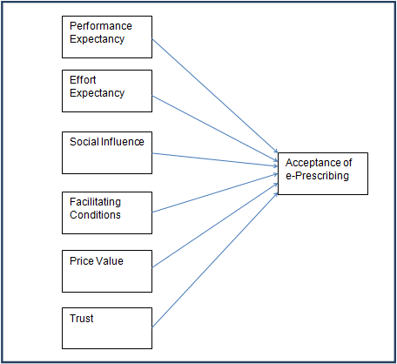
Figure 1 – Research Model
UTAUT identifies three direct determinants of a technology’s acceptance. These are Performance Expectancy, Effort Expectancy and Social Influence.
Performance expectancy is the perceived gains a user will achieve from using a system in their job context through direct improvements to work productivity and/or quality [14]. e-Prescribing has the potential to improve the quality of the scripting process [2, 3, 7]. However, some studies raised concerns that using an online scripting system may create few time savings for physicians and can take significantly longer than simply writing a script [1, 8].
Effort Expectancy denotes the degree to which the use of a system is perceived to be free from physical or mental effort [22]. Perceptions of increased effort would discourage physicians from using an e-prescribing system. Frustrating features of the technology might include clinically irrelevant alert messages that need to be dismissed [1], and unnecessary complexity added to the scripting process [6].
Social Influence is an individual’s perception that important others believe he or she should be using the technology in question [14, 23]. Physicians are likely to have varying perceptions as to whether important others, such as professional bodies or their patients and colleagues, would support and approve of their use of e-prescribing.
The updated UTAUT model [17] has included two additional direct determinants of acceptance.
Facilitating conditions are the resources needed by an individual to make use of a system [14]. An individual’s perception of resource availability acts as a behavioural control influencing their decision on whether or not to make use of the technology [17]. Inadequate technical support and limited onsite technology resources have been identified amongst the barriers to e-prescribing [12], while financial resources to run e-prescribing systems have also been considered important [2, 6].
Price Value perception is an individual’s evaluation of the net gain that could be derived from system use. If physicians have to bear the cost of implementing and using the technology but experience few direct benefits then they will have little incentive to adopt [11, 12].
Finally, we considered the importance of trust beliefs. Trust in a technology is defined as a user’s belief that the technology has attributes beneficial to the user, will behave in a dependable manner and in the interests of the user, and will perform according to the user’s expectation [24]. Trust is relevant in the e-prescribing context due to the potential for risk and liability if an e-prescribing system should prove to be unreliable or inaccurate, e.g. displaying incorrect medication or patient information or failing to adequately safeguard patient information. Trust has been suggested as a potential barrier to acceptance of e-prescribing systems [6, 12]. If a physician believes that an e-prescription system cannot be counted on to function in a consistent and reliable manner, it is unlikely that he or she will be accepting of it.

Methods
Data was collected via a cross-sectional survey methodology. A structured questionnaire was used to capture information from physicians who were familiar with e-prescribing systems. A sampling frame was constructed from a list of 379 physicians provided by an e-prescription application provider and a list of 260 physicians extracted from the South African Yellow Pages and having valid email addresses. This provided a combined sample of 639 potential respondents.
To capture the UTAUT variables, the survey made use of multi-item, 5-point Likert type-scales. The survey items are presented in Appendix. All items were sourced from the literature. Performance and effort expectancy were each measured with six scale items adapted from [14, 22, 23]. Social Influence was measured with three items from Ajzen [25] and Yi, Jackson, Park & Probst [26], Trust was measured with four items [27], Price Value was measured with three items [17] , and technology acceptance was measured using Venkatesh et al.’s [14] three item behavioural intention scale.
Physicians were also provided an opportunity to add qualitative comments.
Ethics clearance was obtained from the relevant review committee at the University of the Witwatersrand, Johannesburg (protocol number: CINFO/1021). The cover letter and link to the online questionnaire was sent via email.
The instrument was pilot tested with 2 physicians prior to its administration.

Results
A total of 78 physicians responded to the survey, but after removing responses with large amounts of missing data or those with outlying response patterns, 72 usable responses remained.
75% of the responding physicians were male, roughly 25% were between 30-45 years of age and 50% were between 45 and 60 years.
Approximately one-third of the responding physicians reported that they use or have trialed e-Prescribing systems.

Quantitative Findings
The mean response to each of the scale items is presented in Appendix 1.
Prior to analysing correlations amongst the studies variables, we ran a principal components factor analysis with varimax rotation to confirm the convergent and discriminant validity of the scales. Five items were dropped at this stage before a stable 7 factor solution explaining 88.6% of the variance could be extracted. The remaining items all loaded onto their expected theoretical factors with loadings of at least 0.65. Cronbach’s alpha confirmed the reliability of the scales. Descriptive statistics are reported in Table 1 below. Composite scores were then computed for each of the scale items for use in subsequent analysis.
There was generally a high level of acceptance of e-prescribing amongst the responding physicians (m=4.03). 12.5% of the responding physicians were over 65 and they exhibited the lowest acceptance scores. Acceptance is however generally comparable to findings in other countries [e.g. 3].
Table 1 illustrates the Spearman correlations between Acceptance and each of the UTAUT factors. All the variables are significantly correlated with acceptance at the p<0.05 level or better. Performance expectancy, trust and price value are the three variables most strongly correlated with acceptance. This suggests that physicians must believe benefits from use will accrue and will outweigh the time spent prescribing electronically. Some past studies found that capturing certain e-prescriptions took longer than writing prescriptions by hand. Any difficulties in using e-prescribing systems are likely to prevent expected benefits from being realized. Physicians may be less willing to accept if they perceive systems to be high effort e.g. having high learning curves, poor usability and a cause of frustration. The benefits will also need to exceed the monetary costs associated with running e-prescribing systems. Low levels of trust also appear to be a hindrance to acceptance. Physicians must believe e-prescribing systems will be free or error and capable of delivering on expectations. Facilitating conditions has only a moderate correlation with acceptance. This suggests that resources and technical infrastructure may already be available in some medical practices. However, our qualitative results presented later will highlight that this may not be the case for all physician practices.
48% of the responding physicians reported having done their own research into e-prescribing but others reported learning about it from other physicians (28%). To further probe the relevance of social influence we compared physician acceptance scores based on how they had learned about e-prescribing. Physicians who had heard about e-prescribing from fellow physicians were somewhat more likely to accept e-prescribing (m=4.32) than those who reporting learning about it from other sources (m=3.81) or their own research (m=3.97).
Table 1 – Descriptive Statistics
Variable | No. of items | Mean  (std dev) | λ | α | ρ
Acceptance | 3 | 4.03 (.98) | .67 | .97 | -
Performance Expectancy | 6 | 3.86 (.98) | .75 | .96 | .696***
Effort Expectancy | 4 | 3.95 (.78) | .65 | .87 | .461***
Social Influence | 3 | 2.85 (1.06) | .94 | .97 | .314**
Facilitating Conditions | 2 | 4.18 (.67) | .78 | .78 | .261*
Trust | 3 | 3.56 (.88) | .66 | .88 | .533***
Price Value | 3 | 3.46 (.89) | .89 | .97 | .474***
α=Cronbach’s alpha reliability, λ=lowest factor loading, ρ = Spearman correlation
*** p<0.001 ** p<0.01 * p<0.05

Physician computer experience (ρ=-0.039) and age (ρ=-.099) did not correlate significantly with acceptance. A t-test also showed no significant differences in acceptance between male and female physicians (t=-.486).
There were no significant differences between current users and non-users along any of the variables, except price-value where users had slightly higher perceptions of price-value.

Qualitative Findings
Qualitative comments provided by respondents corroborated much of the quantitative results, especially with regards to factors of performance expectancy and effort expectancy.
In relation to performance expectations, a number of physicians expressed concerns that the technology would negatively impact their process, and were not optimistic about time savings:
“E-scripting is impractical … it is best to use traditional methods. Handing a patient a script improves therapeutic intervention, makes the service personal and in my opinion is better than facing a PC sending scripts out. Technology is great but it must not affect personal care.”
“too time consuming to use during a consultation.”
“I tried to use e-scripting but I still save a lot of time just writing them by hand”
“Takes more time than writing a script - not cost effective”
“My practice works more speedily & efficiently when scripts are hand written.”
On the other hand, other physicians were more optimistic about the potential of the technology to improve performance:
“[e-prescribing software X] eliminates all the errors in dosing, and at the same time the software itself has in-built ICD10 coding which is now a pre requisite to prescribing patient treatment.”
“Makes for easier record keeping and fits into a more comprehensive ePatient Record System”
In relation to effort expectancy and ease of use, there were also some concerns expressed:
“The user interface is still quite cumbersome ... I don’t use the program much because of the cumbersome nature of it … it is not always on line when I am consulting.”
“Too much admin to use”
“Patients do not like a doctor whose nose is frequently stuck in a computer.”
It was also apparent that vendors can do much to improve usability and ease of use as reflected in this physician’s comment:
“[e-prescribing software Y] was free but not very user friendly. I used it and was great but my software I use now is much more friendly and works for me!!”
Some physician practices may still struggle with the required facilitating conditions. The need for facilitating resources and absence of skills and vendor support led to some frustration in a few practice. For example, some physicians commented:
“[I] do not have the time nor the money for extra staff to capture all the initial data on the computer”
“[The vendor] took more than a month to link me to the system after registering, so I never started using it”
“Need easy step by step explanation setup and how it works and how to use it”
“My current [software] system cannot be updated, ie new medications cannot be added by the suppliers”
“system works but developer has no interest (as per usual) to make it work well, let alone optimal”
Additional insights were also provided with regards to physicians’ broader concerns about the regulatory and technical environments available to support e-prescribing. Broader technical and regulatory issues are still undermining the perceived benefits of the technology, with physicians commenting:
“e-prescribing still requires ink signature to be legal…electronic signature or image should be legalised”
“Interoperability and confidentiality remain the two biggest problems”
“Have yet to find a product that integrates properly with the billing system, but remains fully functional and quick”

Discussion and Conclusion
Diffusion of e-Prescribing systems into physician practice has been slow. This is despite the potential of such systems to improve the quality and safety of the prescribing process. To better understand the perceptions and attitudes of physicians, we carried out a survey of 72 physicians in South Africa.
We found that physicians were generally accepting of the technology with performance expectancy found to be the strongest correlate of acceptance. e-Prescribing systems must therefore be designed to bring direct benefit to the physician in the form of improved productivity and a more effective prescribing process.
Our findings also confirm that e-prescribing is a complex task that required both software and hardware to be optimally configured [8]. e-Prescribing systems must be stable, accurate and perform consistently, and must add value without impacting negatively on the physician’s ability to interact with patients. The systems must be easy to use, and unobtrusive at the point of care.
Moreover, if physicians are responsible for the costs of running and supporting the systems, acceptance will be slow. Financial support and incentives may be important to the technology’s success. In addition, physician practices often lack necessary technology infrastructure and skills. Our findings thus corroborate suggestions [2] that vendor monitoring and outreach are essential to ensure that physicians have up-to-date software and functional hardware. Vendor support can go a long way to removing the frustration and barriers to use, but must be delivered in a reliable manner.
Full benefits and support for the technology may not however be realized until electronic signatures, integration into other eHealth systems, and connectivity into dispensing pharmacy systems are in place [13]. While these issues were raised in qualitative comments, we had not included them in our research model and future research may wish to incorporate these considerations more explicitly.
Future research should consider the hardware platforms, e.g. tablet vs desktop, most supportive of use. Moreover, our performance expectancy scale focused mostly on productivity benefits to the physician. Future work should focus on physician perceptions of benefits e.g. to patient’s experience. Impact studies should be undertaken to confirm the technology’s potential to improve the safety of the scripting process.
Our study was limited in a number of respects. The sampling frame was constructed and thus the generalizability of the findings may be compromised. Moreover, our focus on physicians with email addresses and the use of an online rather than paper-based survey acted as a partial control for computer literacy and PC experience that might bias our findings with regards to the acceptance of e-prescribing. Results are less generalizable to physician groups without email and little computer experience. The cross-sectional nature of data collection also prevents us from drawing any causal inferences with respect to the observed correlations.

References
- Eslami, S, Abu-Hanna, A, and de Keizer, NF. Evaluation of outpatient computerized physician medication order entry systems: a systematic review. J Am Med Inform Assn 2007: 14: 400-06.
- Halamka, J, Aranow, M, Ascenzo, C, et al. E-Prescribing collaboration in Massachusetts: early experiences from regional prescribing projects. J Am Med Inform Assn 2006: 13(3): 239-44.
- Tamblyn, R, Huang, A, Kawasumi, Y, et al. The development and evaluation of an integrated electronic prescribing and drug management system for primary care. J Am Med Inform Assn 2006: 13(2):148-59.

- van der Sijs, H, Aarts, J, Vulto, A, and Berg, M. Overriding of drug safety alerts in computerized physician order entry. J Am Med Inform Assn 2006: 13: 138-47.
- Johnson, KB, Ho, YX, Cala, CM, and Davidson, C. Showing your work: impact of annotating electronic prescriptions with decision support results. J Biomed Inform 2010: 43(2): 321-5.
- Smith, AD. Barriers to accepting e-prescribing in the USA. Int J Health Care Qual Assur 2006: 19(2): 158-80.
- Ammenwerth, E, Schnell-Inderst, P, Machan, C, and Siebert, U. The effect of electronic prescribing on medication errors and adverse drug events: a systematic review. J Am Med Inform Assn 2008: 15(5): 585-600.
- Devine, EB, Hollingworth, W, Hansen, RN et al. Electronic prescribing at the point of care: a time–motion study in the primary care setting. Health Serv Res 2010: 45(1): 152-71.
- Kaushal, R, Kern, L, Barrón, Y, Quaresimo, J, and Abramson, E. Electronic prescribing improves medication safety in community-based office practices. J Gen Intern Med 2010: 25(6): 530-36.
- Mäkinen, M., Forsström, J., Äärimaa, M., and Rautava, P. A European survey on the possibilities and obstacles of electronic prescriptions in cross-border healthcare. Telemed J E Health 2006: 12(4): 484-9.
- Chin, T. Five obstacles to e-prescribing. A M News 2003: 46(18): 17.
- Crosson, JC, Etz, RS, Wu, S, et al. Meaningful use of electronic prescribing in 5 exemplar primary care practices. Ann Fam Med 2011: 9: 392-97.
- Mäkinen, M, Rautava, P, Forsström, J, and Äärimaa, M. Electronic prescriptions are slowly spreading in the European Union. Telemed J E Health 2011: 17(3): 217-22.
- Venkatesh, V, Morris, MG, Davis, GB, and Davis, FD. User acceptance of information technology: toward a unified view. MIS Quart 2003: 27(3): 425-78.
- Van Belle, JP. Mobile technology adoption by doctors in public healthcare in the Western Cape, South Africa. In: ECIS 2006 Proceedings, 2006; Paper 102.
- Jones, J. The adoption of internet technology among general practitioners in Kwazulu-Natal. MBA Dissertation: Durban Institute of Technology, 2008.
- Venkatesh, V, Thong, JYL, and Xu, X. Consumer acceptance and use of information technology: extending the unified theory of acceptance and use of technology. MIS Quart 2012: 36(1): 157-78.
- Chang, I, Hwang, H, Hung, W, and Li, Y. Physicians’ acceptance of pharmacokinetics-based clinical decision support systems. Expert Syst Appl 2007: 33: 296-303.
- Kijsanayotin, B, Pannarunothai, S, Speedie, SM. Factors influencing health information technology adoption in Thailand’s community health centers: applying the UTAUT model. Int J Med Inform 2009: 28: 404-16.
- Cilliers, L, and Flowerday, S. Health information systems to improve health care: a telemedicine case study. SA Journal of Information Management 2013: 15(1): art. # 541.
- Wang, CJ, Patel, MH, Schueth, AJ, Bradley, M, Wu, S, Crosson, JC, Glassman, PA, and Bell, DS. Perceptions of standards-based electronic prescribing systems as implemented in outpatient primary care: a physician survey. J Am Med Inform Assn 2009: 16(4): 493-502.
- Davis, FD. Perceived usefulness, perceived ease of use, and user acceptance of information technology. MIS Quart 1989: 13(3): 319-40.
- Holden, RJ, and Karsh, BT. The technology acceptance model: its past and its future in health care. J Biomed Inform 2010: 43(1): 159-72.
- McKnight, DH, Choudhury, V, and Kacmar, C. Developing and validating trust measures for e-commerce: an integrative typology. Inform Syst Res 2002: 13(3): 334-59.
- Ajzen, I. The theory of planned behavior. Organ Behav Hum Dec 1991: 50(2): 179-211.
- Yi, MY, Jackson, JD, Park, JS, and Probst JC. Understanding information technology acceptance by individual professionals: toward an integrative view. Inform Manage 2006: 43: 350–63.
- Garbarino, E, and Johnson, MS. The different roles of satisfaction, trust, and commitment in customer relationships. J Marketing 1999: 63(2): 70-87.

Address for correspondence
XXXXXX
XXXXXX

Appendix 1 – Survey items and Mean Responses
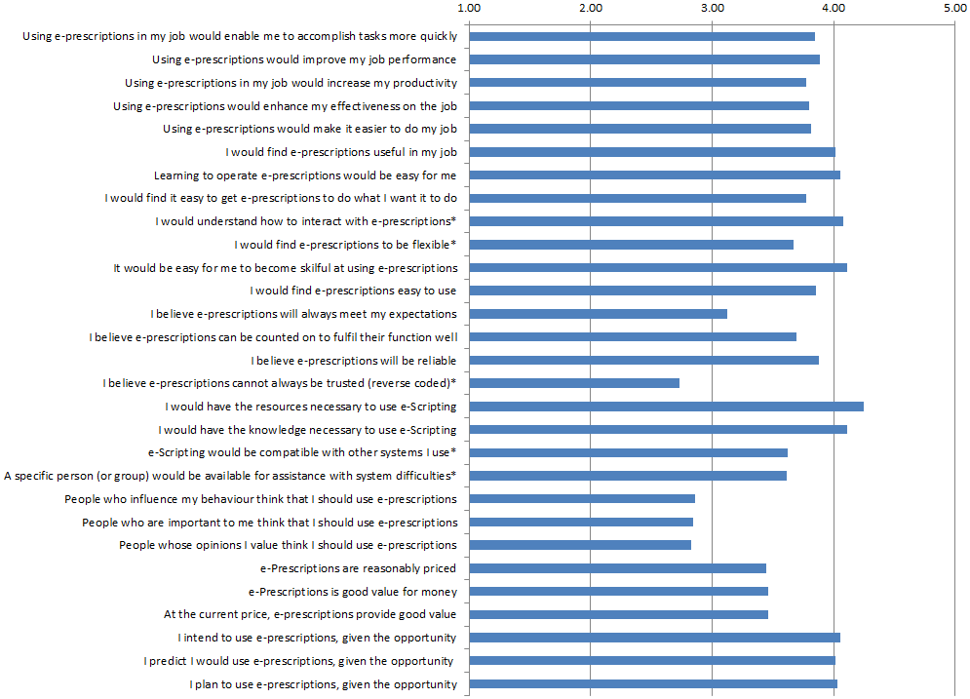
Performance Expectancy
Acceptance
Price Value
Social
Influence
Facilitating Conditions
Trust
Effort
Expectancy

* item dropped from calculation of composite variable scores following principal components analysis

